Report on One-Day Seminar Commemorating the Birth Anniversary of Pandit Ishwar Chandra Vidyasagar

Organized by Department of Physics, Raghunathpur College
Date: 26 September 2026, Venue: Room No. 214, Raghunathpur College, Time: 11:00 AM onwards
The Department of Physics, Raghunathpur College, organized a one-day seminar on 26 September 2026 to commemorate the birth anniversary of Pandit Ishwar Chandra Vidyasagar, the renowned educationist, social reformer, scholar and humanist. The programme was organized in the presence of the Principal of Raghunathpur College, Dr. Phalguni Mukhopadhyay, and was attended by teachers and students of the college.
The seminar aimed to remember Vidyasagar's remarkable contributions to education, social reform, humanism and the intellectual development of Bengal, while also exploring the broader evolution of knowledge and science in the Indian context.
The programme began with an inaugural address by Dr. Phalguni Mukhopadhyay, Principal, Raghunathpur College. In his address, he highlighted the enduring relevance of Pandit Ishwar Chandra Vidyasagar's ideals and his significant contribution to the development of modern education and society in Bengal. He emphasized the importance of carrying forward Vidyasagar's values of education, reason, social responsibility and humanity.
This was followed by an invited lecture by Dr. Soumendra Nath Ruz, Assistant Professor, Ramananda Centenary College, Laulara, entitled “A Lecture on the Bengal Renaissance: Pandit Ishwar Chandra Vidyasagar.” The lecture focused on Vidyasagar's role in the Bengal Renaissance and discussed his contributions to education, social reform and the intellectual awakening of nineteenth-century Bengal. The lecture provided students with an opportunity to understand Vidyasagar's life and work within the wider historical and cultural context of the Bengal Renaissance.
An online lecture was subsequently delivered by Dr. Sukhomoy Bhattacharyya, Associate Professor, Jadavpur University, on the topic “A Look Back to the Indian Knowledge System through the History of Science.” The lecture explored the development of knowledge and scientific thought in India from a historical perspective and encouraged the participants to look at the Indian knowledge tradition through the lens of the history of science. The interactive online session added an interdisciplinary dimension to the seminar.
The programme was attended by a considerable number of students and faculty members. The students participated with interest and attentiveness throughout the lectures. The seminar provided an enriching academic environment and encouraged reflection on the relationship between education, history, science and society.
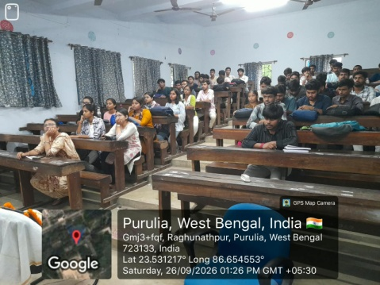
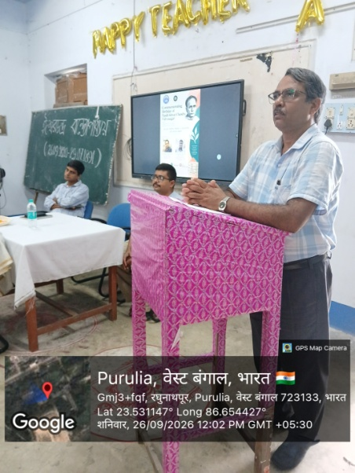
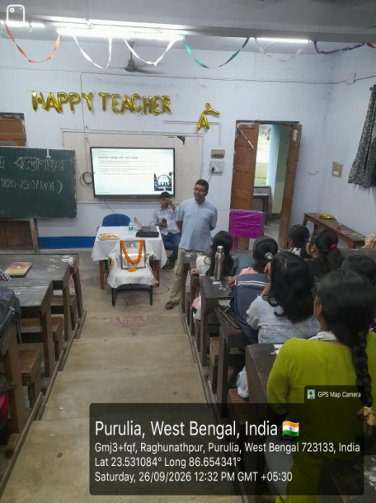
The programme concluded with a note of thanks to the Principal, invited speakers, faculty members and students for their valuable participation and cooperation. The seminar successfully commemorated the birth anniversary of Pandit Ishwar Chandra Vidyasagar and created an opportunity for the participants to reflect upon his enduring legacy as an educationist, reformer and humanist.
