Workshop: Career Opportunities in Research and Development after Graduation with Physics Honours
Date: 02/04/2024
Venue: Raghunathpur College, Department of Physics
______________________________________________________________________________________________________

Speakers:

Dr. Prasanta Gorai, Alumni of Department of Physics, Raghunathpur College, and Postdoctoral Fellow at Institute of Theoretical Astrophysics, University of Oslo, Norway.

Dr. Pappu Acharya, Alumni of Department of Physics, Raghunathpur College, and Postdoctoral Fellow at Lund University, Sweden.

Introduction: Department of Physics, Raghunathpur College organized a workshop on "Career Opportunities in Research and Development after Graduation with Physics Honours" on 02/04/2024. This workshop aimed to provide insights into various career options available for Physics graduates, particularly in research and development fields.
Key Points Covered:
Entrance Exams and Preparation: The speakers discussed about various entrance exams particularly as JAM (Joint Admission Test for M.Sc.), JEST (Joint Entrance Screening Test) and GATE (Graduate Aptitude Test in Engineering) that students can appear to pursue higher studies after graduation. They emphasized on the importance of thorough preparation for these exams and provided tips on effective study techniques.
Facing Interview Boards: The speakers shared their experiences and insights on facing interview boards for academic and research positions. They highlighted the significance of confidence, communication skills, and subject knowledge during interviews. Additionally, they offered guidance on how to present oneself professionally and effectively during interviews. They assured that language may not be a barrier at this stage , but one should keep on learning English for future.
Preparation for Pursuing Ph.D.: Dr. Acharya and Dr. Gorai provided valuable advice on preparation of Ph.D. They discussed the importance of selecting the right research area based on one's interests and career goals. They also shared their own experiences during their Ph.D. journey including conducting research, writing research papers and collaborating with peers and professors.
Ph.D. Experience: The speakers shared their experiences during their Doctoral Research, focusing on their research areas of condensed matter physics and astrophysics. They discussed the challenges and rewards of pursuing Ph.D. programme that includes conducting experiments, analyzing data and publishing research findings. They also highlighted the opportunities for international collaborations and networking in the field of physics research.
Interactive Session:
Following the presentations, students were engaged in an interactive session with the speakers, asking questions and seeking advice on various aspects of pursuing a career in research and development. The queries ranged from specific entrance exam preparation strategies to insights into different research areas within Physics. The speakers patiently listened to them and addressed each query, providing guidance and encouragement to the students.
Conclusion:
The workshop on "Career Opportunities in Research and Development after Graduation with Physics Honours" provided students with valuable insights and guidance for their future academic and career pursuits. The informative presentations by Dr. Gorai and Dr. Acharya, along with the interactive session, enriched the students' understanding of the diverse opportunities available in the field of physics research and development.
Acknowledgment:
Department of Physics expresses gratitude to Dr. Prasanta Gorai and Dr. Pappu Acharya for sharing their expertise and experiences with the students. Special thanks goes to Teacher-In-Charge, Raghunathpur College Dr. Srinibas Nandy and IQAC Coordinator, Raghunathpur College Dr. Jyoti Prakash Mandal for extending their help and support to organize the workshop and making it successful.
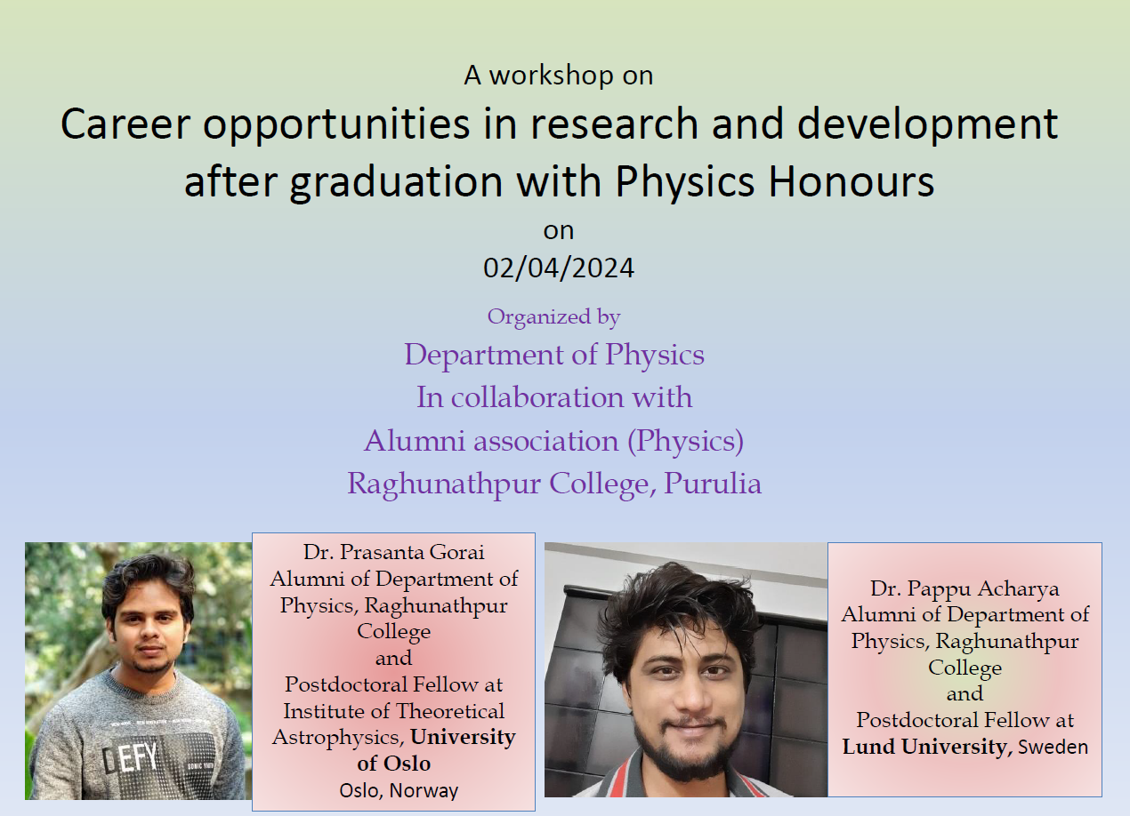
The Flyer of the programme
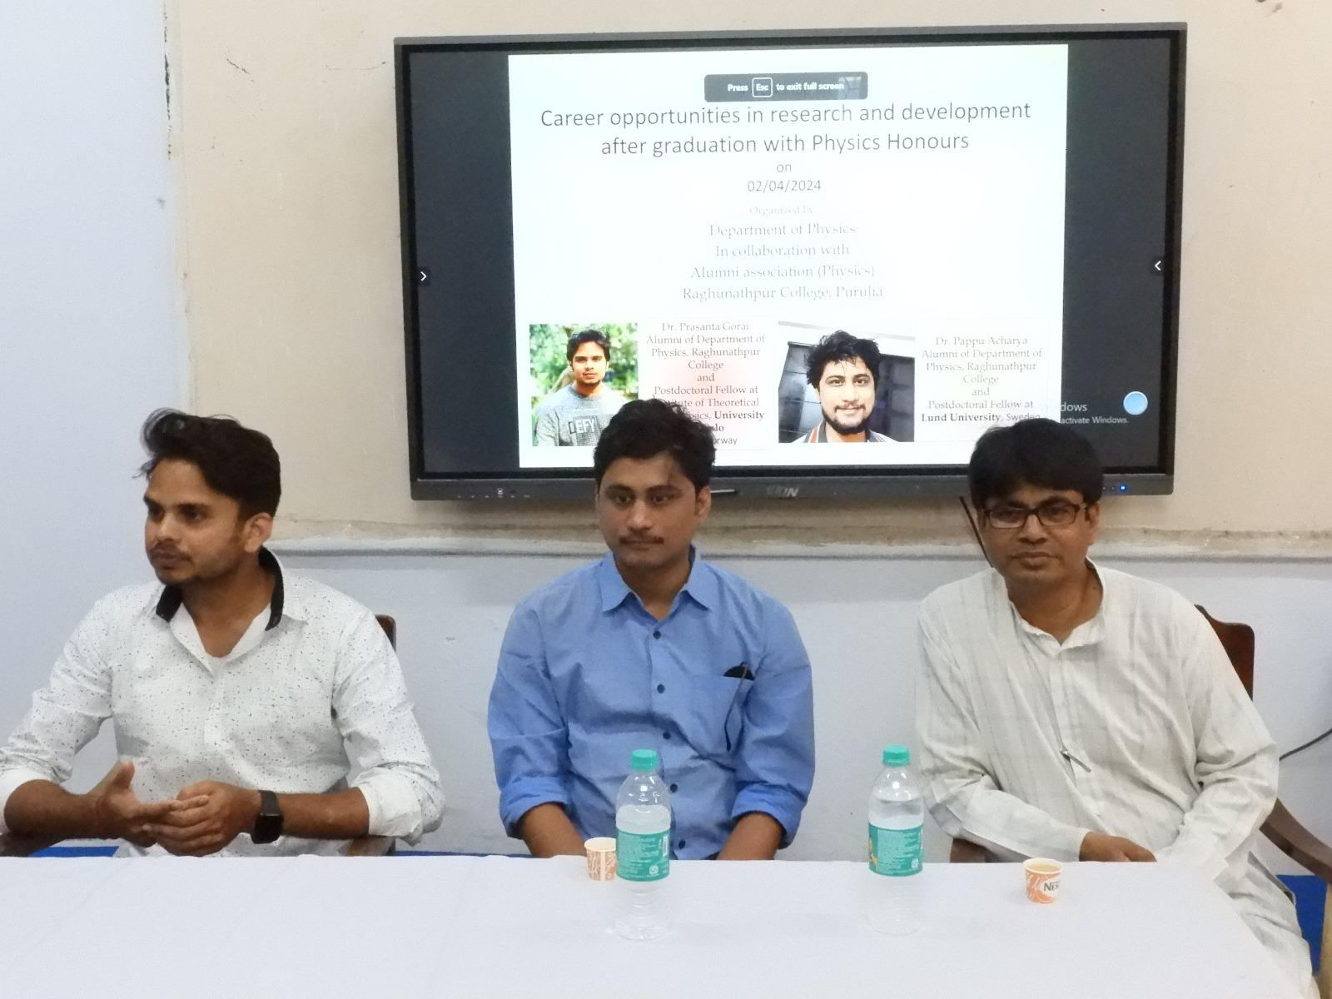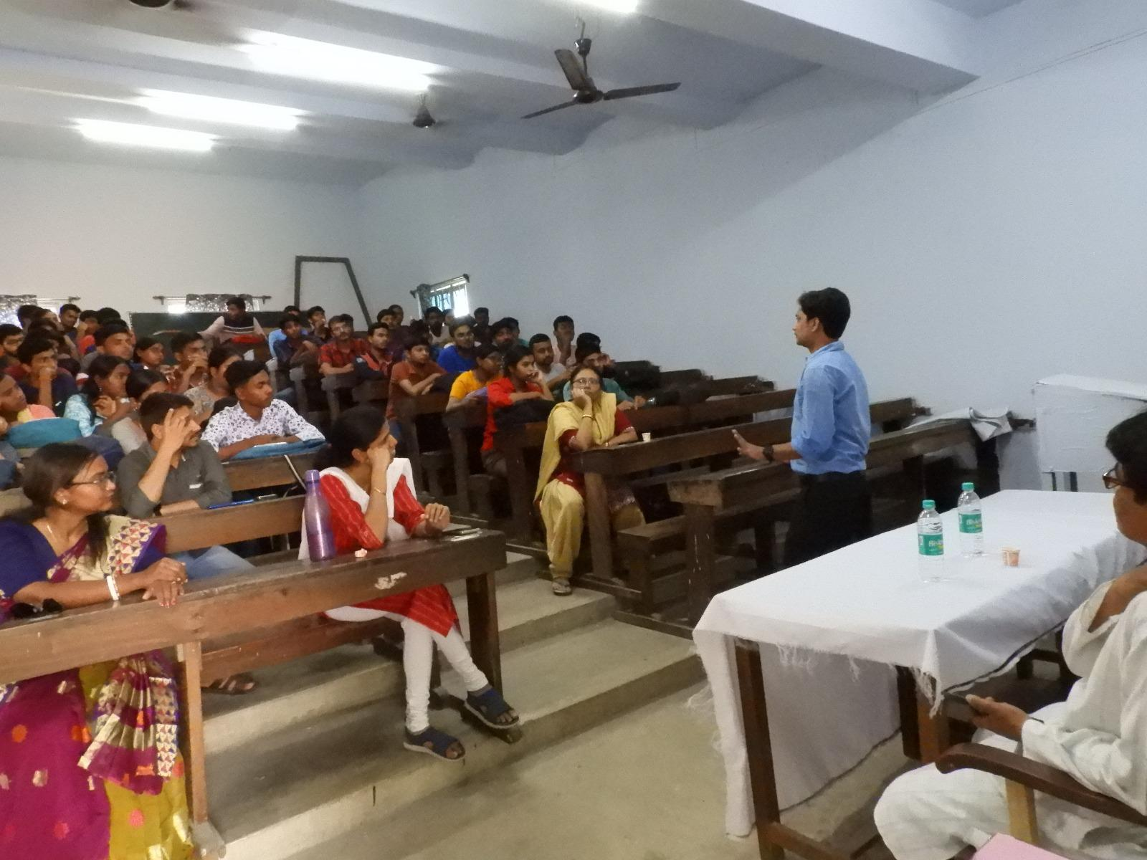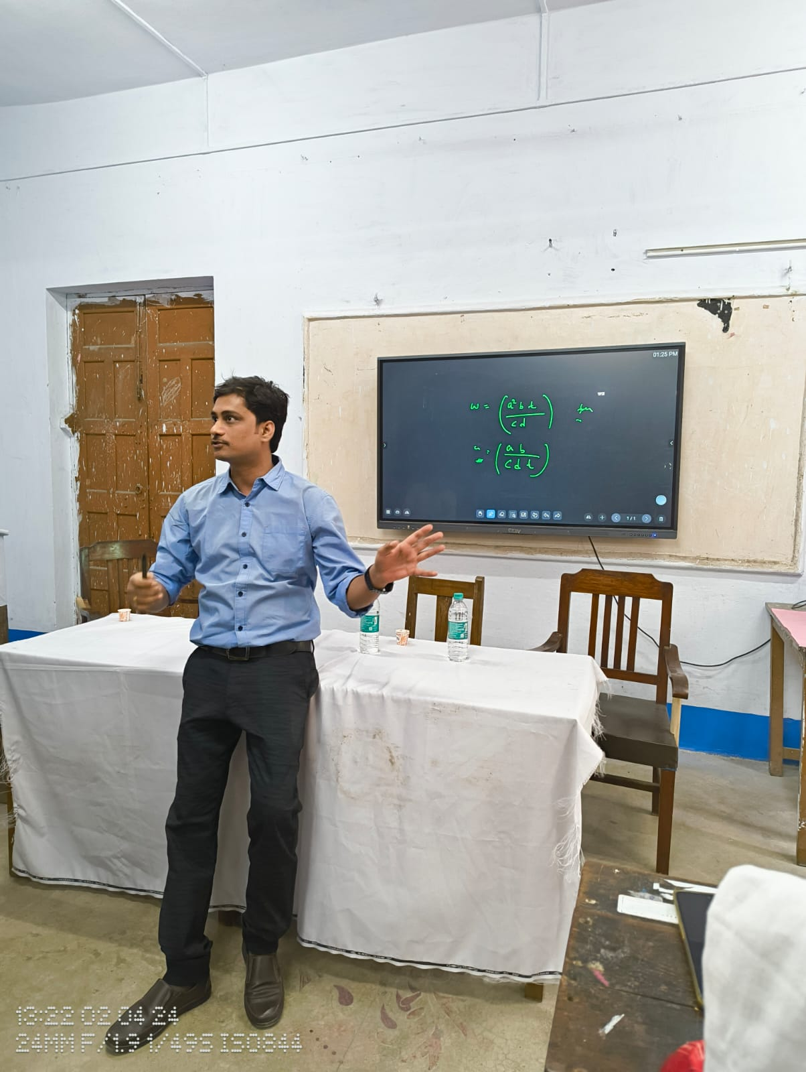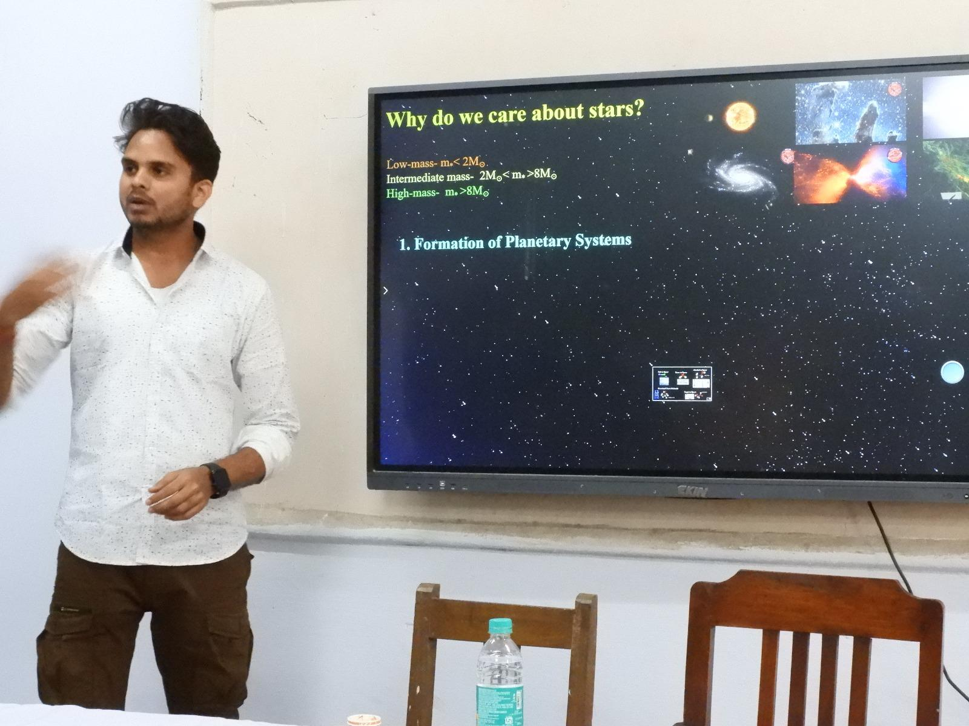
Glimpses of the Workshop

